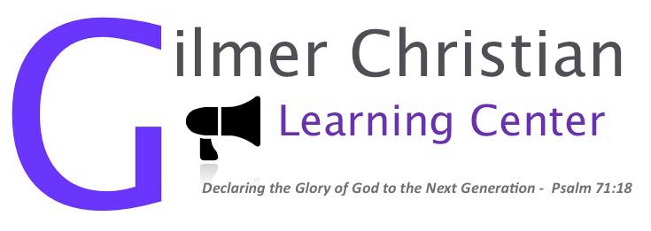Dear Sir or Madam,
You have been identified as a potential sponsor for our 2016 Gilmer Christian Learning Center 5K- Run for the Son. The CLC is a Released Time Education Non-Profit that has been serving the students of Gilmer County since 1985. We offer free Bible classes to public school students as well as counseling and a mentor program at no charge to students or families.
The 10th Annual Run for the Son is an opportunity for us to raise awareness about the CLC and to raise funds so that we can continue helping students and families and expand our programming.

A. Platinum Level - $1,000
1. Recognition as a Platinum Level Sponsor during the 5K
2. Recognition as a Platinum Level Sponsor on Race shirt
3. One time recognition in the CLC Newsletter
4. Link to your website from our website: www.gilmerclc.org
5. Recognition as a Platinum Level Sponsor in the Times-Courier w/ company logo
6. Vendor booth at race event
7. Your banner near the race start/finish
8. Your flyer in race packet
9. Four race entries
B. Gold Level - $500
1. Recognition as a Gold Level Sponsor during the 5K
2. Recognition as a Gold Level Sponsor on the Race shirt
3. One time recognition in the CLC Newsletter
4. Recognition as a Gold Level Sponsor in the Times-Courier
5. Vendor booth at race event
6. Your flyer in race packet
7. Your banner at the race start/finish
8. Three race entries
C. Silver Level - $250
1. Recognition as Silver Level Sponsor during the 5K
2. Recognition as a Silver Level Sponsor on the Race shirt
3. One time Recognition in the CLC Newsletter
4. Recognition as a Silver Level Sponsor in the Times-Courier
5. Vendor booth at race event
6. Your flyer in race packet
7. Two race entries
D. Bronze Level - $100
1. Recognition as a Bronze Level Sponsor during the 5K
2. Recognition as a Bronze Level Sponsor on the Race shirt
3. One time Recognition in the CLC newsletter
4. Recognition as a Bronze Level Sponsor in the Times-Courier
5. One race entry

